INSTRUCTIONS TO ASSEMBLE AND TEST
THE TAPR "TICC" TIMESTAMPING COUNTER
08 January 2017

FIXTURE CONFIGURATION:

The test fixture is a panel of three "PulsePuppy" circuit boards, each with a 10 MHz oven oscillator and digital divider. Two of the boards are configured for "1 PPS" output (a jumper across the top pins of the header, with the BNC facing to the right) and the third is jumpered for "10 MHz" output (jumper across the bottom two pins of the header). See illustration below.

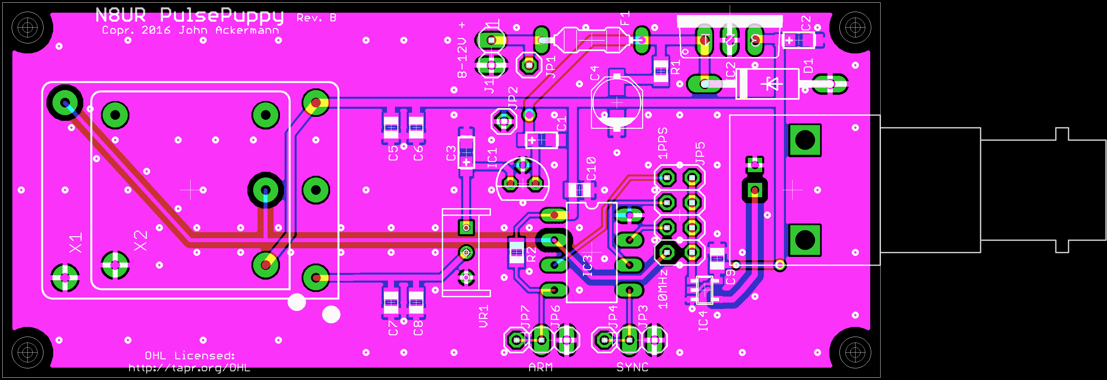

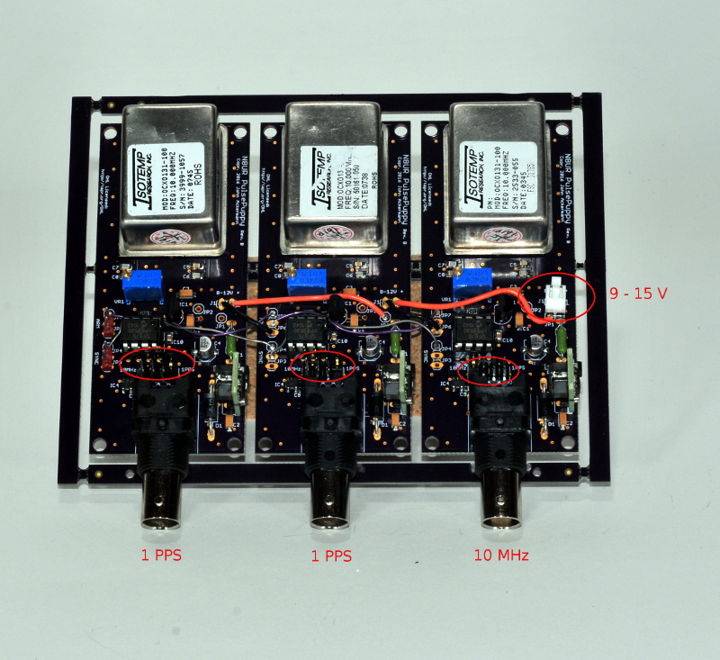

Attach the provided power cable to the test fixture and to a source of 9 – 15 volts DC (red lead is positive). Initial current drain is about 1 amp; steady-state is about 250 ma. It is best if the system can be powered continuously.

ASSEMBLY/UPLOAD/TEST PROCEDURE:

1. Burn the "PD15.HEX" file into the 12F675 chip and install the chip into the 8-pin socket on the TICC.

2. Mate the TICC shield to the Arduino Mega 2560 board.

3. Use the provided BNC-to-SMA cables to connect to the TICC as shown below. Connect the "10 MHz" output from the test fixture to the "10 MHz IN" SMA connector on the TICC. Connect the two "1 PPS" outputs to the "Channel A" and "Channel B" SMA connectors on the TICC (order not important). Connect USB cable from Arduino to host computer.

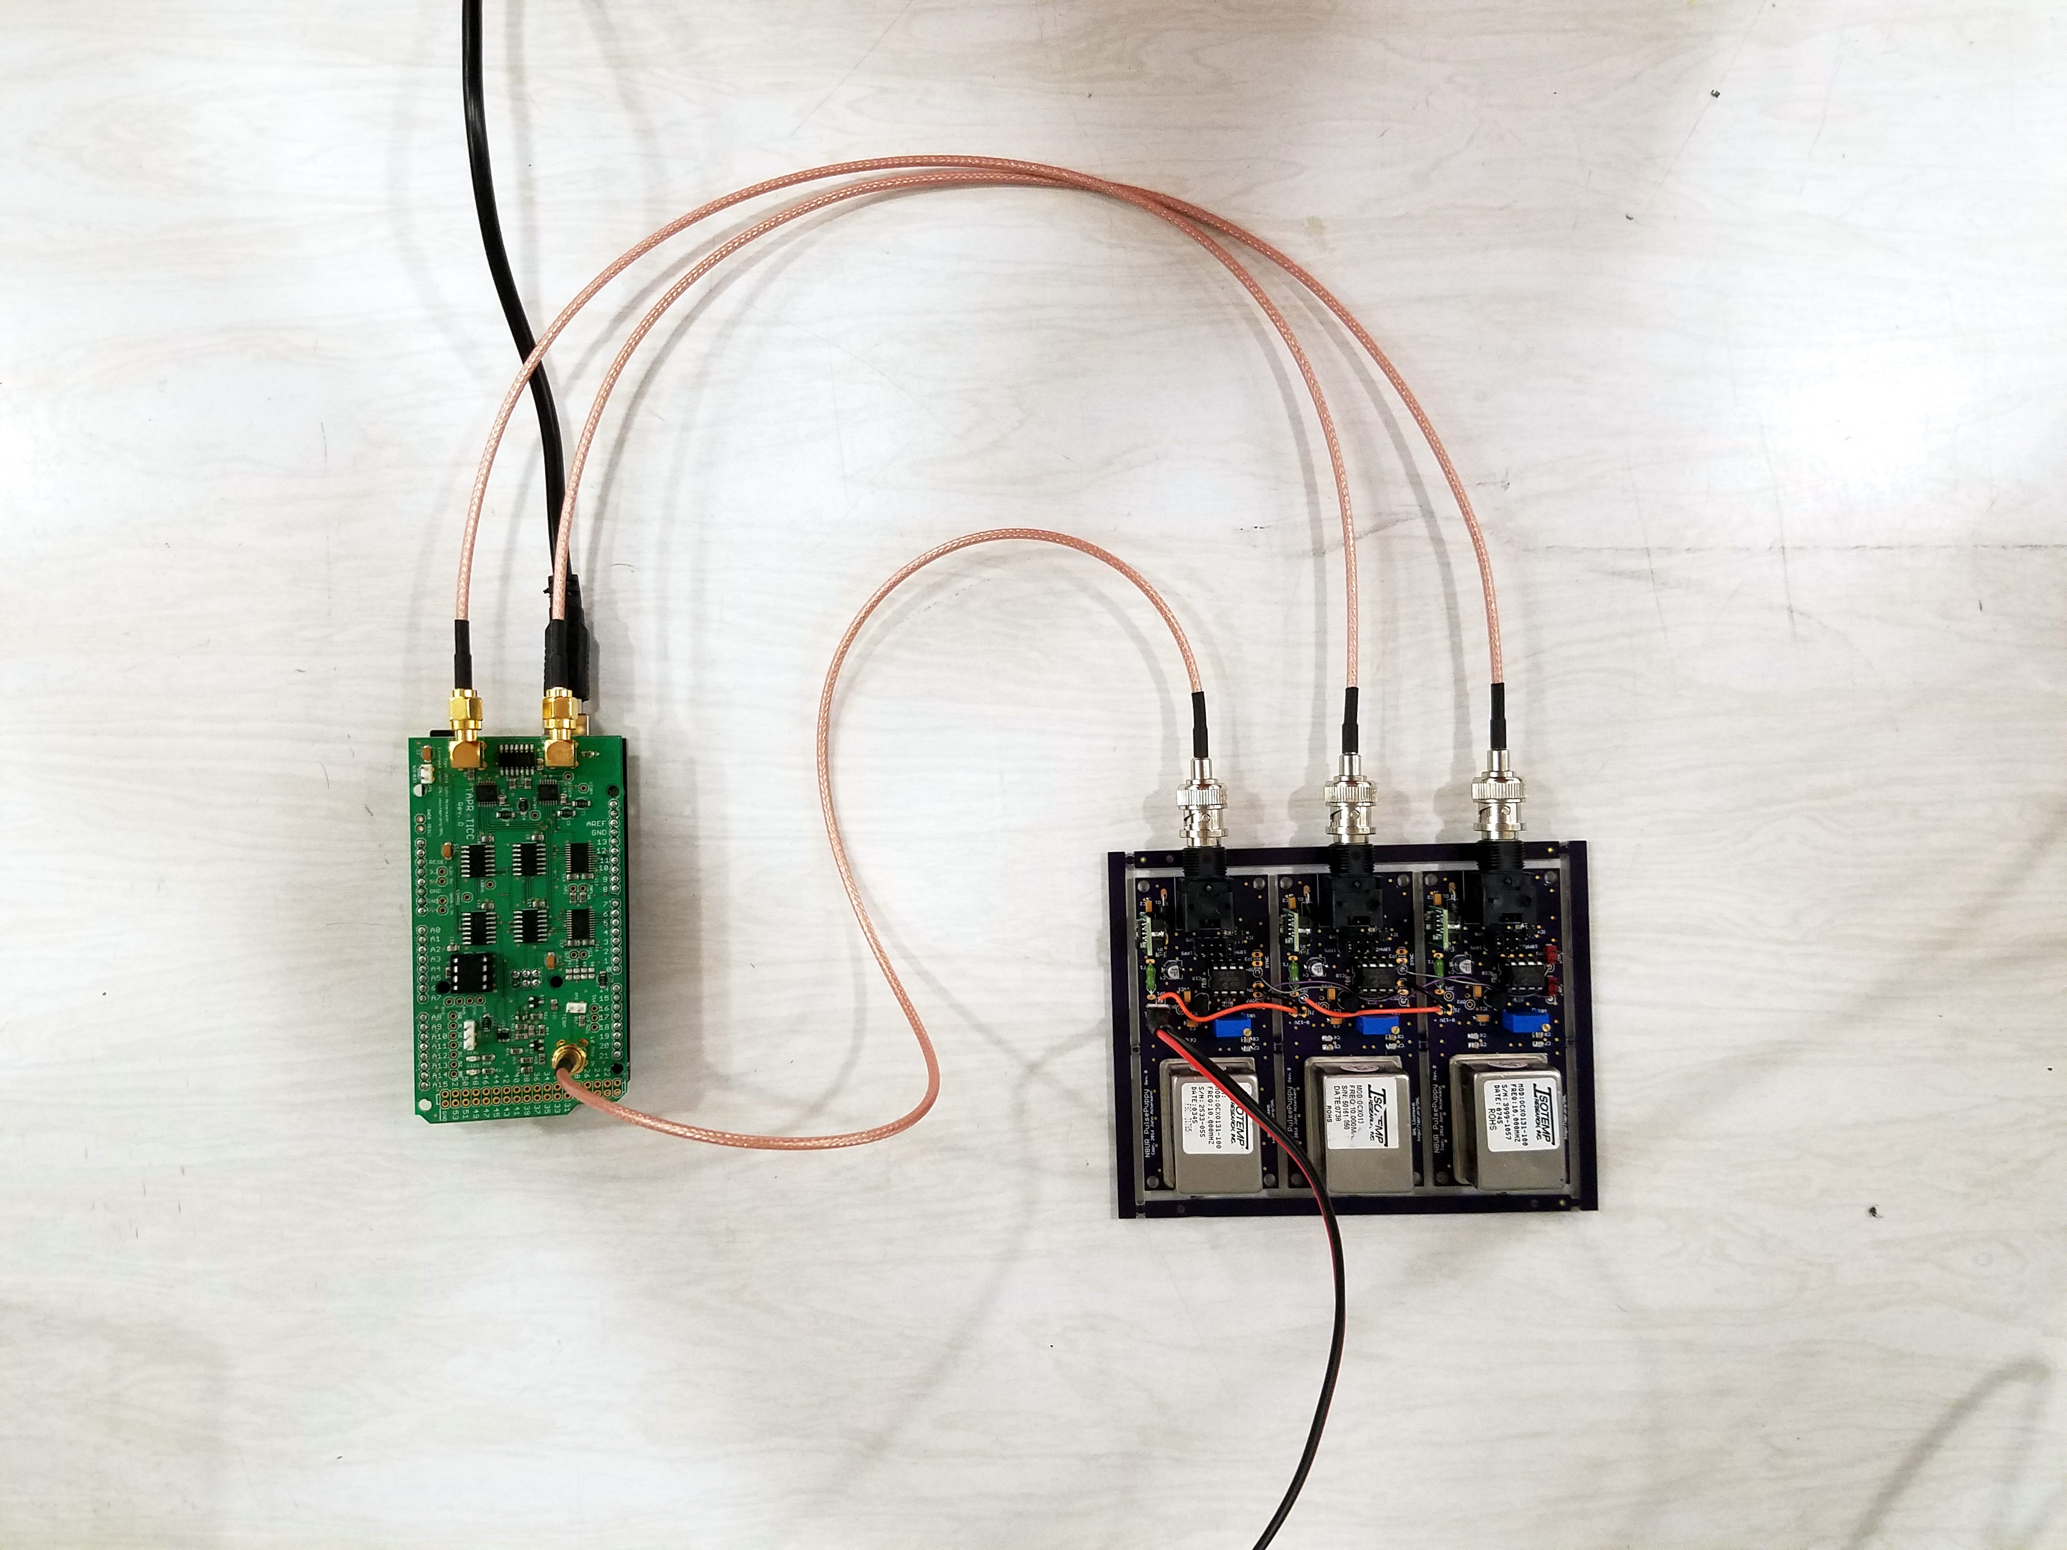

2. Open the "Xloader" software on the Windows computer. Browse to the location of the "TICC.ino-20170108.1.hex" file. Select board type "Mega (ATMEGA2560)" and select the appropriate com port. Set baud rate to 115200. Click "Upload" and after a few seconds the program should indicate the number of bytes sent, as shown below.

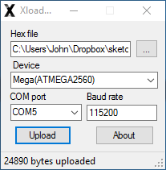

3. Now open a serial terminal program (set to 115200, N, 8, 1). You may see an initial message saying that a serial number is being written. After a few seconds, you should see a screen similar to the following:

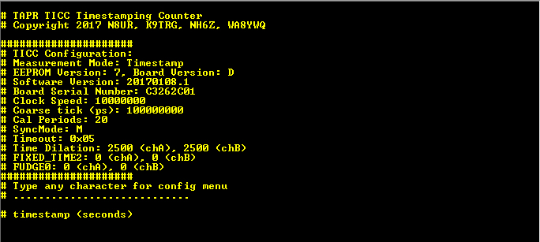

The reported versions may be different. If any non-standard characters are displayed, or numeric values do not match what is shown here, there is a problem with the upload.

4. If the signal cables are properly connected, after a few seconds data should start appearing and will look like this:

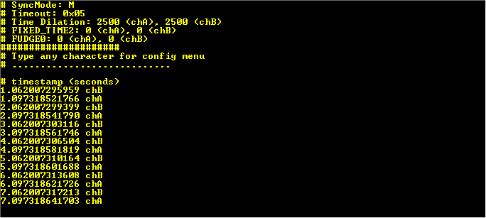

You should see lines ending alternately with both "chA" and "chB" (which comes first is not important), with the first pair having either the number 1 or 2 to the left of the decimal point. The integer part of each pair of readings should increment by 1.

If both of these screens are correct, the TICC and Arduino are working properly and the unit is ready for packaging.

